CRISP-DM Process – Retail Case

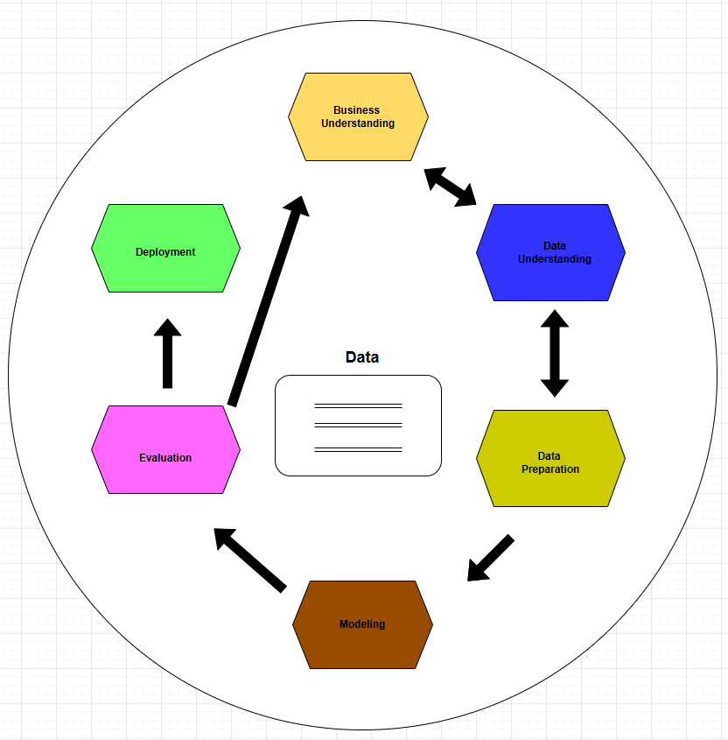

Business Understanding:
- Determine business objectives.
  - Increase sales during peak season by understanding customer buying behavior.
- Assess situation.
  - Review past seasonal sales and current marketing strategies to identify challenges.
- Determine data mining goals.
  - Use historical purchase data to predict which products to promote.
- Produce project plan.
  - Create a timeline and assign team roles for data collection, modelling, and deployment.
Data Understanding:
- Collect initial data
- Gather sales transactions, customer loyalty data, store locations, and online orders.
- Describe the data
- Summarize key fields like purchase date, product ID, customer ID, and store region.
- Explore the data
  - Look for missing values, outliers, or unexpected trends (e.g., sudden drops in sales).
- Verify data quality
  - Ensure data is complete, accurate, and consistent across different store branches.
Data Preparation:
- Select data
  - Choose data from the last 12 months and focus on top-selling product categories.
- Clean data
  - Remove duplicate transactions and correct errors in pricing or product IDs.
- Construct data
  - Create new fields such as “holiday season flag” or “total basket value per customer.”
- Integrate data
  - Merge sales, inventory, and customer profile data into a unified dataset.
Modelling:
- Select modeling techniques
  - Choose decision trees and clustering to identify purchase behavior and customer segments.
- Generate test design
  - Split data into training and tests sets to evaluate model performance reliably.
- Build model
  - Train model to forecast product demand and segment customers by purchase patterns.
- Assess model
  - Check metrics like accuracy and precision to determine how well the model performs
Evaluation:
- Evaluate results
  - Test if the model correctly predicts demand for top-selling items during holidays.
- Review process
  - Double-check if all data preparation and modeling steps follow business requirements.
- Determine next steps
  - Decide whether to refine the model or move forward with deployment based on accuracy and business relevance.
Deployment
- Plan deployment
  - Outline how model insights will be used in inventory restocking and marketing campaigns.
- Plan monitoring and maintenance
  - Set up alerts and regular checks to ensure the model still performs well as new sales data arrives.
- Produce final report
  - Deliver a report detailing goals, methods, findings, and ROI projections to leadership.
- Review project
  - Hold a post-mortem to identify what went well, what didn’t, and how future projects can improve.

Data Detective – Mini Retail Dataset
Customer ID | Purchase Amount | Payment Method | Product Category | Store Location | Loyalty Member
1001 | 54.99 | Credit Card | Clothing | New York | Yes
1002 | 23.5 | Cash | Accessories | Miami | No
1003 | 120 | Credit Card | Electronics | New York | Yes
1004 | 35.25 | Mobile Pay | Clothing | Chicago | No
1005 | 88.1 | Cash | Electronics | Miami | Yes

- What are the instances? The instances are individual customer transactions (rows).
- What are the features? The features (columns) that describe each transaction are:
- Customer ID
- Purchase Amount
- Payment Method
- Product Category
- Store Location
- Loyalty Member
- Which features are categorical? Which are continuous?
- Categorical
- Payment Method (e.g., Credit Card, Cash)
- Product Category (e.g., Clothing, Electronics)
- Store Location (e.g., New York, Miami)
- Loyalty Member (Yes/No)
- Continuous
  - Purchase Amount (numeric currency value)
- ID-type (not used in modeling):
  - Customer ID (an identifier, typically not a predictive feature)
- Is this data labeled or unlabeled? If the goal is to predict something like Loyalty member, Product Category, or Payment Method using the other features. These can serve as labels in a supervised learning task. If the goal is to group similar customers without a specific label using Clustering, then the data is unlabeled data.

